Lesson 4 Demo 13: Configure a Configmap as a File in the Pod

This section will guide you to:

* Configure a configmap as a file in the pod

This lab has one sub-section, namely:

1. Configuring a configmap as a file in the pod

**Note:** If you don’t have an existing Kubernetes cluster, refer to the Demo 1.1 of Lesson 1.

**Step 1:** Configuring a configmap as a file in the pod

* Start the kubernetes cluster in the lab
* As the first step, download the file *game.properties* file as shown below and create the local directory using   
    
  *sudo mkdir -p configure-pod-container/configmap/*
* Download the sample files into *configure-pod-container/configmap/* directory

*sudo wget https://kubernetes.io/examples/configmap/game.properties -O configure-pod-container/configmap/game.prop*

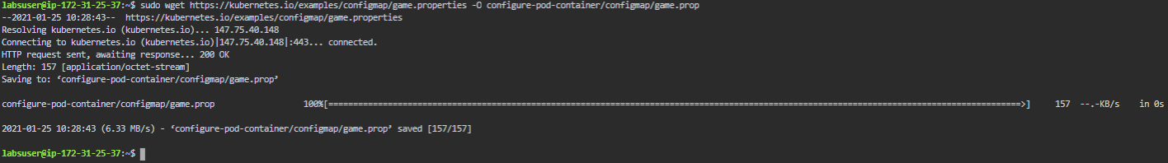

* You can use kubectl create configmap to configure a ConfigMap from an individual file or from multiple files as shown below. ConfigMap will be configured as per the attributes mentioned in Config File

*kubectl create configmap game-config-2 --from-file=configure-pod-container/configmap/game.properties*

* You can verify the configured config map using **kubectl describe configmaps game-config-2** command as shown below:

